CAS PY 106

Lecture Note 29

1. What happens when light hits a dense material?
2. 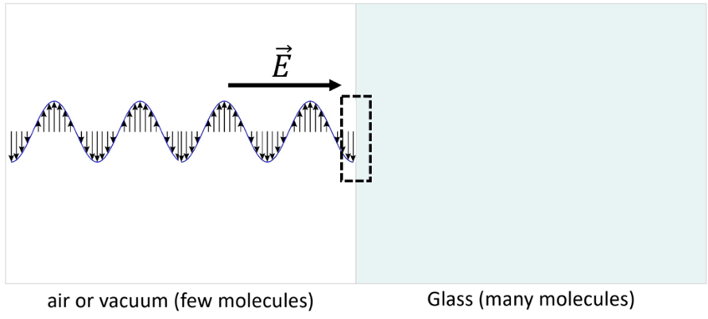
3. This very complicated interaction produces a new wave
4. It has the same frequency because the electrons at the interface are driven at the same frequency as the incoming wave
5. But it has a slower speed
6. Since v = wavelength \* frequency is always true, the wavelength must decrease also
7. 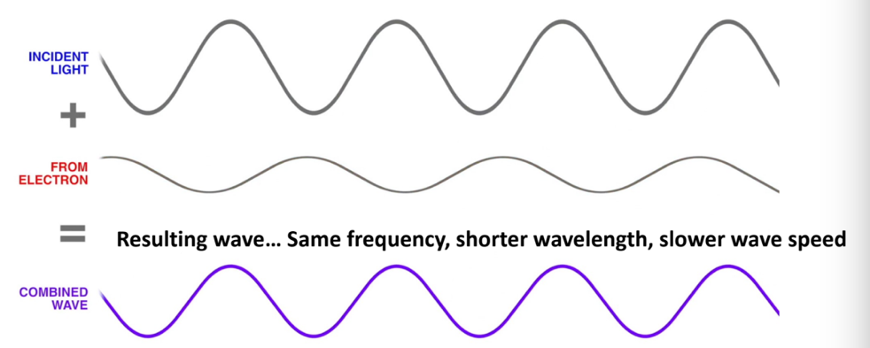
8. Index of Refraction n
9. N is the factor by which the speed of light decreases in a material
10. 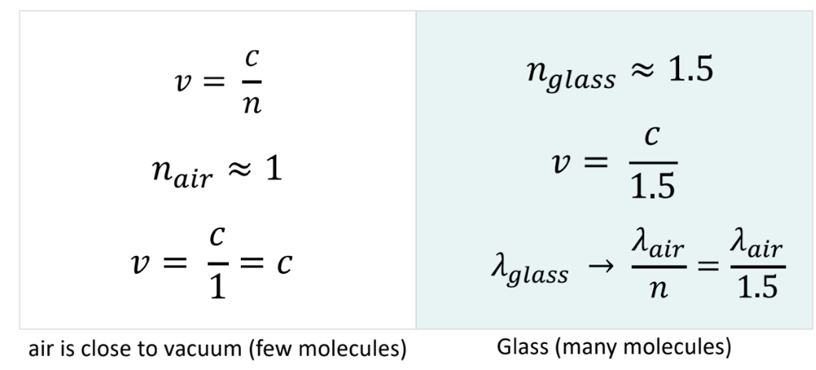
11. 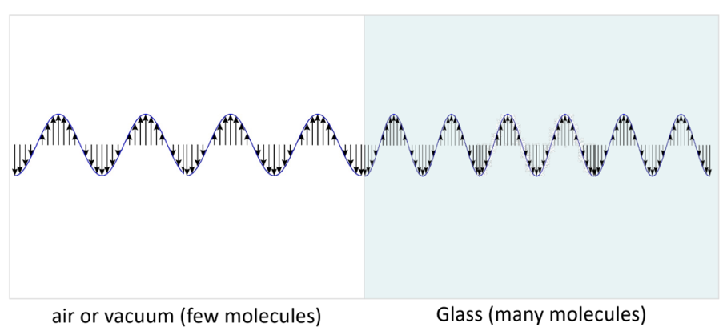
12. n depends on material (vacuum, air, etc. are all n=1)
13. Typically n bigger when “more dense”
14. N is also called “refractive index”
15. 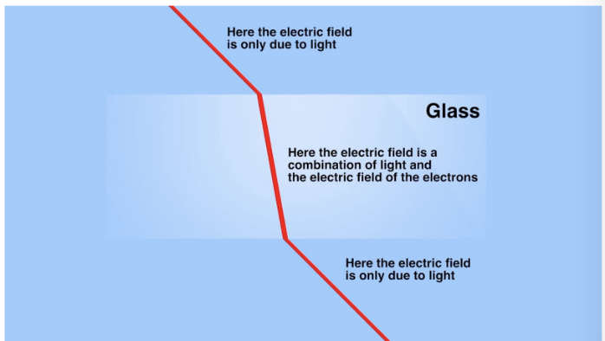
16. Light enters glass, slows down, and bends
17. Snell’s Law
18. 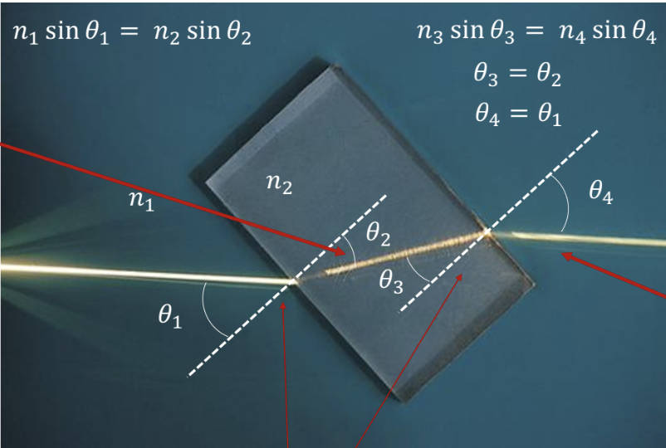
19. When n1 to n2 (low index to high index), light bends toward the normal
20. N1\*sin(theta)1 = n2\*sin(theta)2

v = c / n2

wavelength = wavelengthair / n2

1. When n3 to n4 (high index to low index), light bends away from the normal
2. N3\*sin(theta)3 = n4\*sin(theta)4

v = c

wavelength = wavelengthair

n4 = n1 = 1

1. In general, when light hits a change in refractive index…
2. Some light is reflected according to the law of reflection
3. Some light is refracted (transmitted and bent) according to Snell’s law:

N1\*sin(theta)1 = n2\*sin(theta)2

1. LOW index of refraction to HIGH index of refraction
2. 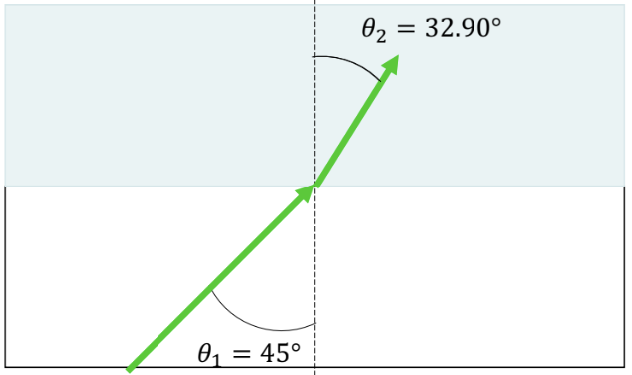
3. water, n =1.333 (blue area)
4. air, n = 1.0 (white area)
5. Snell’s Law:

1 \* sin(45degree) = 1.333 \* sin(theta)

sin(theta) = sin(45degree) / 1.333

sin(theta) = 0.530

theta = 32.9 degrees

1. HIGH index of refraction to LOW index of refraction
2. 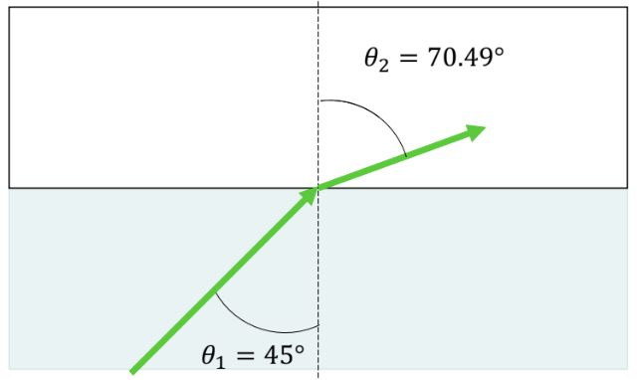
3. air, n = 1.0 (white area)
4. water, n = 1.333 (blue area)
5. Snell’s Law:

1.333\*sin(45degree) = 1 \* sin(theta)

sin(theta) = 1.333 \* sin(45 degree)

theta = 70.49 degrees

1. As you keep increasing the incident angle, the transmitted light moves further and further away from the normal line
2. What happens when theta2 hits 90?
3. 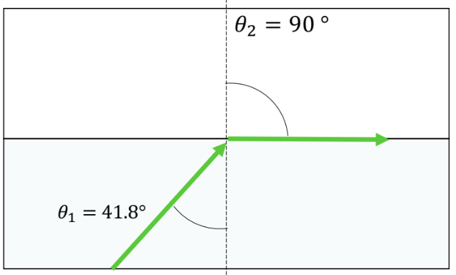
4. At this point, theta1 = 41.8 degrees is the critical angle, thetac, and light incident beyond this angle is totally reflected back into medium1!
5. 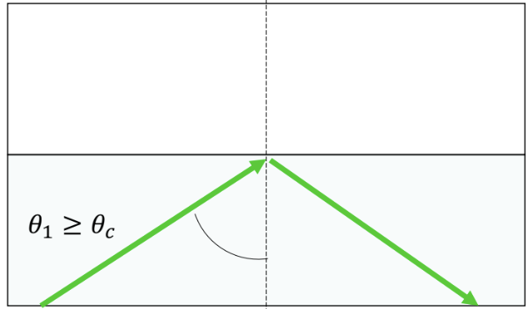
6. Refraction Example
7. If the refracted ray follows path D, not bending at all, what can you conclude?
8. 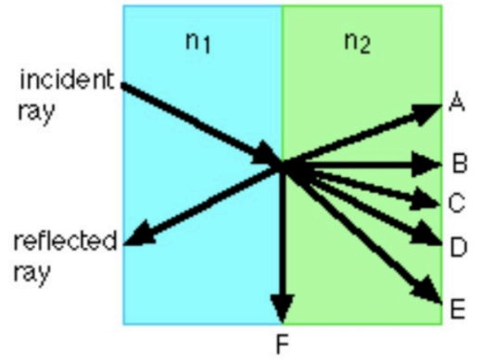
9. n1 = n2